**GENERIC METHOD**

**01/08/24**

1) write a java program to create generic method that take list of numbers and return the sum of all even and odd number

Code

import java.util.List;

public class NumberSum {

public static <T extends Number> void calculateSum(List<T> numbers) {

double sumEven = 0;

double sumOdd = 0;

for (T number : numbers) {

if (number.doubleValue() % 2 == 0) {

sumEven += number.doubleValue();

} else {

sumOdd += number.doubleValue();

}

}

System.out.println("Sum of even numbers: " + sumEven);

System.out.println("Sum of odd numbers: " + sumOdd);

}

public static void main(String[] args) {

List<Integer> intList = List.of(1, 2, 3, 4, 5, 6);

calculateSum(intList);

}

}

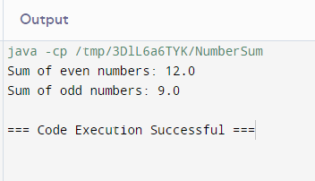

2) write a java program to create generic method that take list of any types and a target element it return the index of first occurece of the target element in the list return -1 the target element cannot be found

CODE

import java.util.List;

public class FindElementIndex {

public static <T> int findFirstOccurrence(List<T> list, T target) {

for (int i = 0; i < list.size(); i++) {

if (list.get(i).equals(target)) {

return i;

}

}

return -1;

}

public static void main(String[] args) {

List<Integer> intList = List.of(1, 2, 3, 4, 5);

List<String> strList = List.of("JESSY", "nandhU", "TEJU");

System.out.println("Index of 3 in intList: " + findFirstOccurrence(intList, 3));

System.out.println("Index of 'JESSY' in strList: " + findFirstOccurrence(strList, "APPLE"));

System.out.println("Index of 'KARTICK' in strList: " + findFirstOccurrence(strList, "grape"));

}

}

